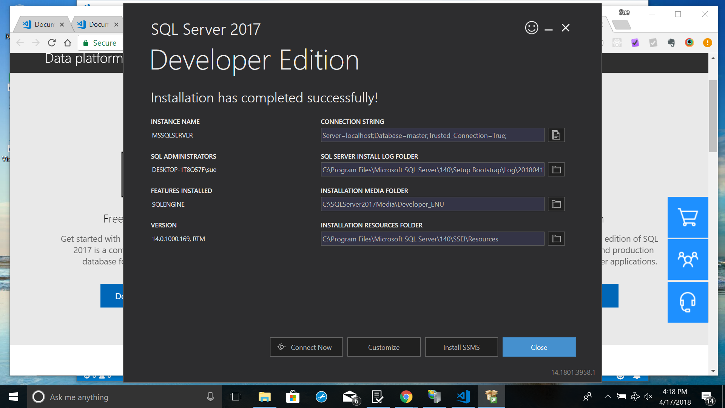

Connection string: Server=localhost;Database=master;Trusted_Connection=True;